Singapore



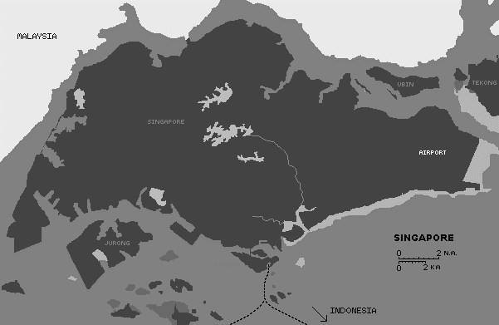

Manoj Vasa

GEG 1300-003 Human Geography

Mike Reinker

Population and health

Total recorded population as of 2014 in Singapore was approximately 5.47 million.

Number of citizens included 3.34 million, number of permanent residents consisted of 530,000 people, and 1.60 million non-residents in the year of 2014.

With this large population, however, growth rate has decline to 1.3% in 2014.

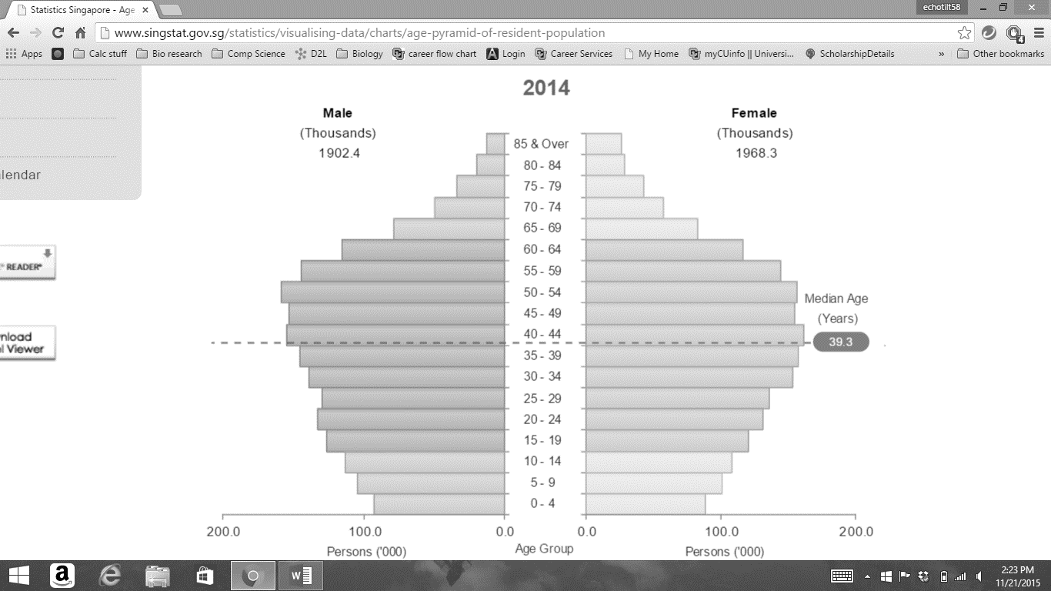Population growth rates in previous years:

2005-2010 : 3.5%

2011 : 2.1%

2012 : 2.5%

2013 : 1.6%

2014 : 1.3%

As we can see in these population pyramids, the median age is 39 years and it seems to be steadily increasing. Here are the median ages for previous years:

* 2002: 34.7 years
* 2004: 35.4 years
* 2006: 36.1 years
* 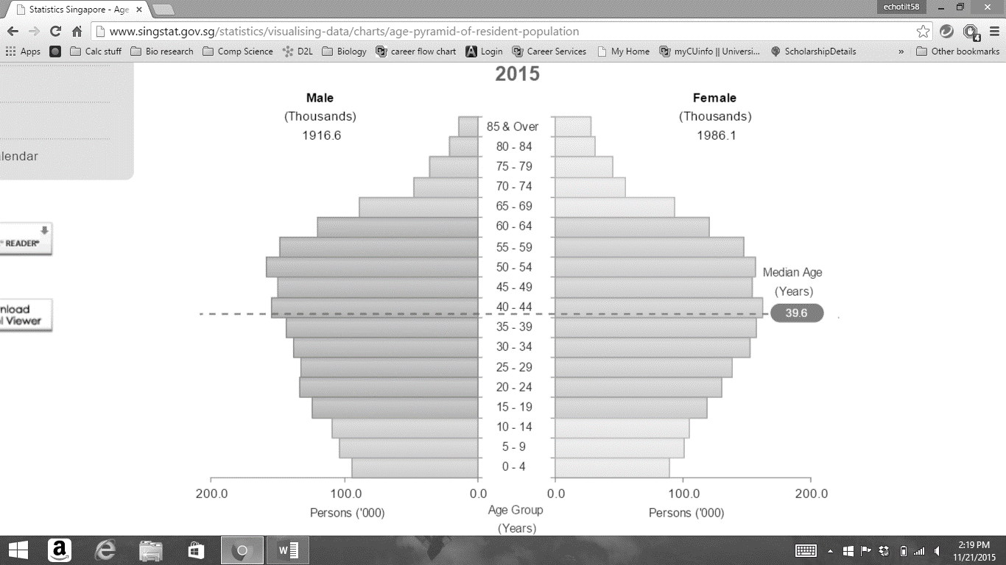2008: 36.7 years
* 2010: 37.4 years
* 2012: 38.4 years

The median age in Singapore has been slightly and consistently increasing through the years.

Migration

Singapore was originally a trading colony established by the British in 1819. At this time, the population was only a couple hundreds. As time went on however, immigrants rushed into Singapore in search for work in a growing market. With these new immigrants population grew from a couple hundred to approximately 500,000 by 1931. Most of these immigrants came from China, Japan, and the Malay Archipelago. This expansion of population was seized with the temporary occupation of the Japanese during World War II.

After the war, in the 1960’s, Singapore has enacted stricter regulations and laws to limit the amount of immigrants to only those who can positively contribute to the socioeconomic development of the city-state. Singapore’s industry flourished in the 1980’s and opened up many new jobs and attracted many immigrants from foreign nations. Foreigners also immigrated to Singapore as students. Thus, the nonresident population of Singapore has increased till present day as it became the top center of business and finance.

As stated before the number of non-citizen population in Singapore is:

* 530,000 permanent residents
* 3.87 million residents
* 1.60 million non-residents
  + Immigrants with work passes and foreign students

As of recently, however, there has been a major problem of emigration of Singaporean Citizens. Records show that about 192,000 Singaporeans live overseas. These overseas locations consist of Australia, Great Britain, the United States, and China. Among these countries, Australia consists of the most emigrated Singaporeans. Most of these emigrants were high skilled workers searching for better work. Consequently, Singapore has been facing a brain-drain for the past few years.

As many Singaporeans have been emigrating from their homes for more opportunities overseas, there has been a developing immigration problem that has been causing concern to the Singaporean Government. Such concern has resulted in the government enacting and enforcing new laws and regulations to limit the consequences of this situation. Due to Singapore’s xenophobic stance to the foreigners that are occupying their city-state, aggression and hostility towards them only made their lives worse. Many strikes and protests were held by the Chinese and the South-Asian population due to unfair treatment. However, these protests and strikes only raised hostility to the foreign workers that weren’t even involved in the incidents.

Language

Along with the abundance of diversity that exists in Singapore, types of languages are also correspondingly abundant. Among the many languages in Singapore the five most popularly spoken languages consist of Mandarin, English, Malay, Tamil, and the Chinese language Min Nan.

* Mandarin : 1,210,000 speakers
* English : 1,100,000 speakers
* Malay : 414,000 speakers
* Min Nan : 333,000 speakers
* Tamil : 111,000 speakers

Including these two languages of Chinese hearth there appears to be five total variation of Chinese languages present in Singapore. This could suggest that as there are many people who emigrated from China, they were also from various regions of the vast China region.

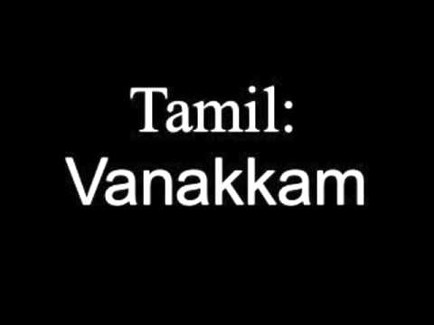



Religions

The five major religions present in Singapore are:

* Buddhism (33.0% of Singapore poplation)
  + Practices teachings of morality, concentration and wisdom
  + Mahayana Buddhism is the most practiced form in Singapore
  + Largest Mahayana Buddhism temple is the Kong Meng San Phor Kar See Monastary
  + 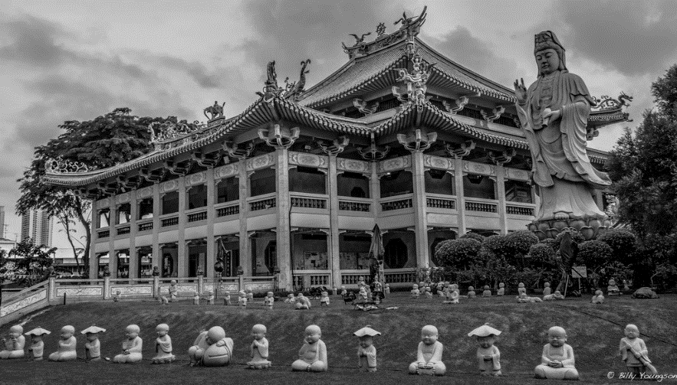The image below is the Kong Meng San Phor Kar See Monastary:
* Taoism(10.9% of Singapore population)
  + This religion believes in respecting heaven, worshipping ancestors and being compassionate to everyone under heaven.
  + Developed the concept of ying yang; dark and light.
  + The oldest Taoist temple in Singapore is Thian Hock Keng (Temple of Heavenly Happiness) was built in 1842.
  + 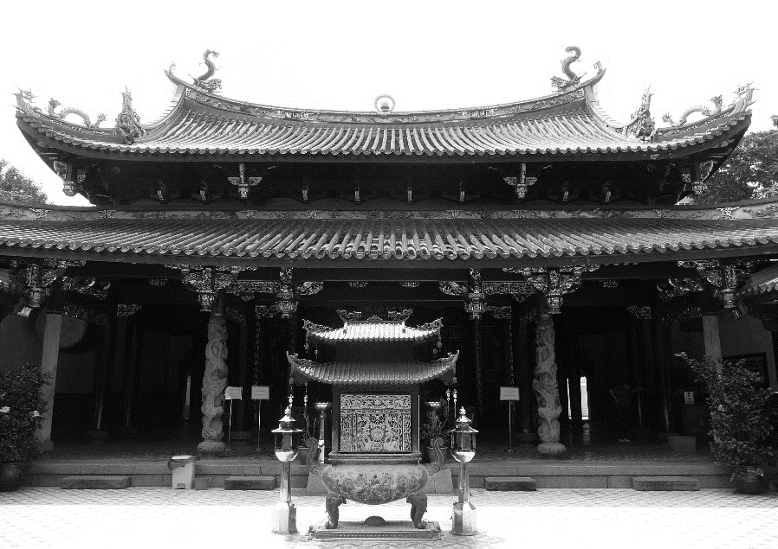The image below is the Thian Hock Keng temple:
* Islam (14.7% of Singapore population)
  + Study the teachings inscribed in the Quran
  + Approximately 16% of Singaporeans are Islamic
  + The first president of Singapore, Yusof bin Ishak, was Islamic and his face is still imprinted on the currency to this day
  + Masjid Sultan is the oldest Mosque in Singapore.
  + 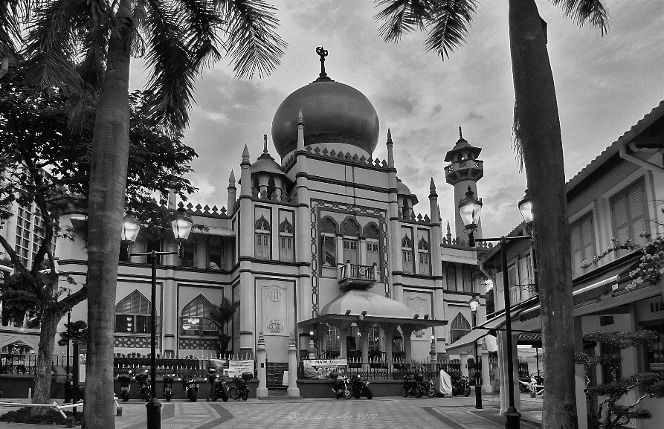The following image shows the Masjid Sultan Mosque:
* Christianity (18.3% of Singapore population)
  + Follows the teaches of Jesus written in the Bible
  + Oldest Christian Church, the Armenian Church, was built in 1835
  + 30 Catholic churches present in Singapore
  + 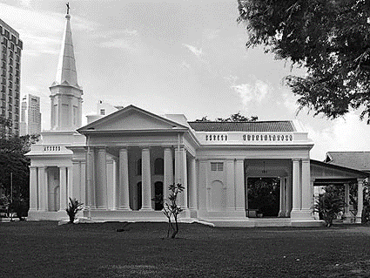The Armenian Church is presented in the image below:
* Hinduism (5.1% of Singapore population)
  + Followers of Hinduism believe that the supreme god takes various forms as the creator, the preserver, and the destroyer.
  + The oldest religion in the world
  + 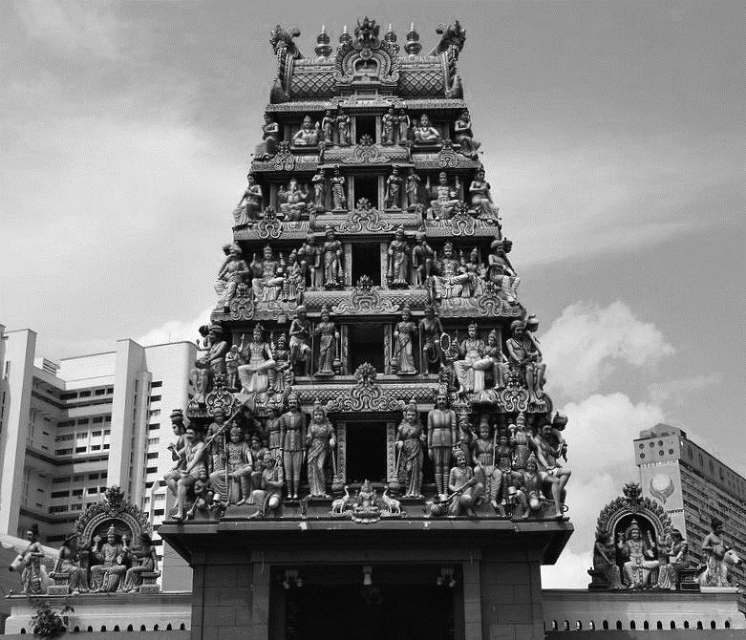Oldest Hindu temple in Singapore is built in 1827

Evidently, 17% of the Singapore population is non-religious. This constitutes to nearly the same amount of people that practice Christianity.

Ethnicity

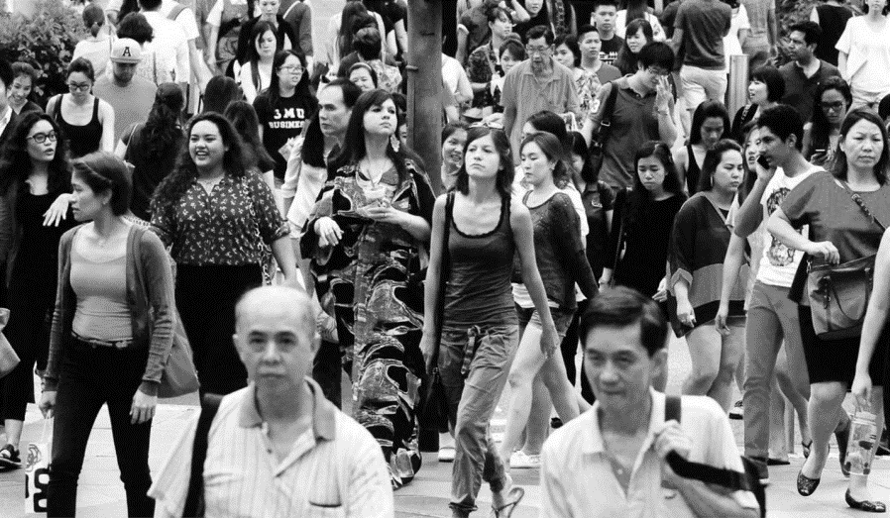Ethnic distribution in Singapore:

* 75.9% of population is Chinese
* 12.1% of population is Malay
* 9.1% of population is Indian

Culture (Food and Festivals)

Singapore consists of many diverse ethnicities and religions which contribute to the further diversifying culture. Some Chinese festivals consist of Lunar New Year, Qingming Festival, Vesak Day, and the Mid-Autumn Festival. Some Hindu festivals consist of Deepavali, Thaipusam, and Navratri.

* Lunar New Year
  + Lunar New Year, also known as Chinese New Year, is celebrated on February 8th on the first day of new moon.
* Qingming Festival
  + The Qingming Festival was celebrated this year on April 5. This festival it to celebrate the first day of the fifth solar term in the Chinese Lunisolar calendar.
* Vesak Day
  + This day is celebrated by Buddhists to commemorate the birth, death and enlightenment of Gautama Buddha.

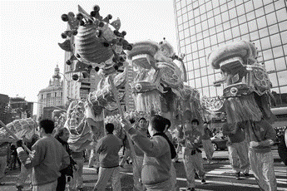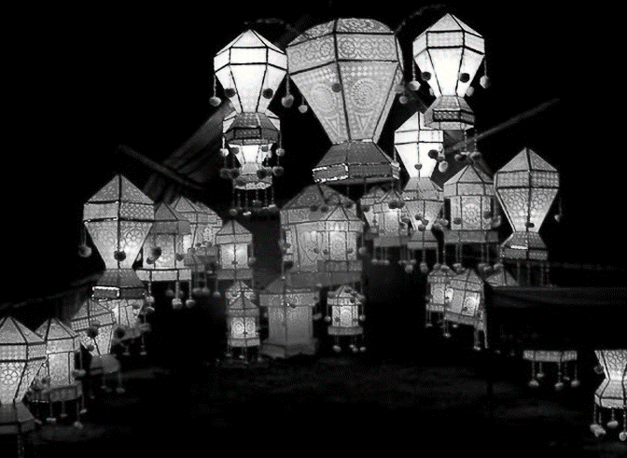

* Mid-Autumn Festival
  + This festival was celebrated on the full moon of Sunday, September 27 this year and is devoted to the 15th day of the eight lunar month.
* Deepavali
  + A festival of light celebrating Lord Rama returning home after defeating the evil demon Ravana.
* Thaipusam
  + A Hindu ceremony that is held every year on the full moon on the tenth month of the Hindu calendar.
* Navratri
  + A Hindu festival devoted to the glorification of the nine forms of Shakti, the feminine form of the Devine. This festival lasts nine days with each day devoted to each of the nine forms

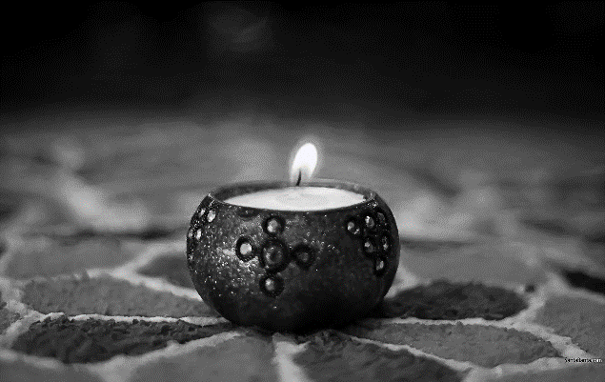

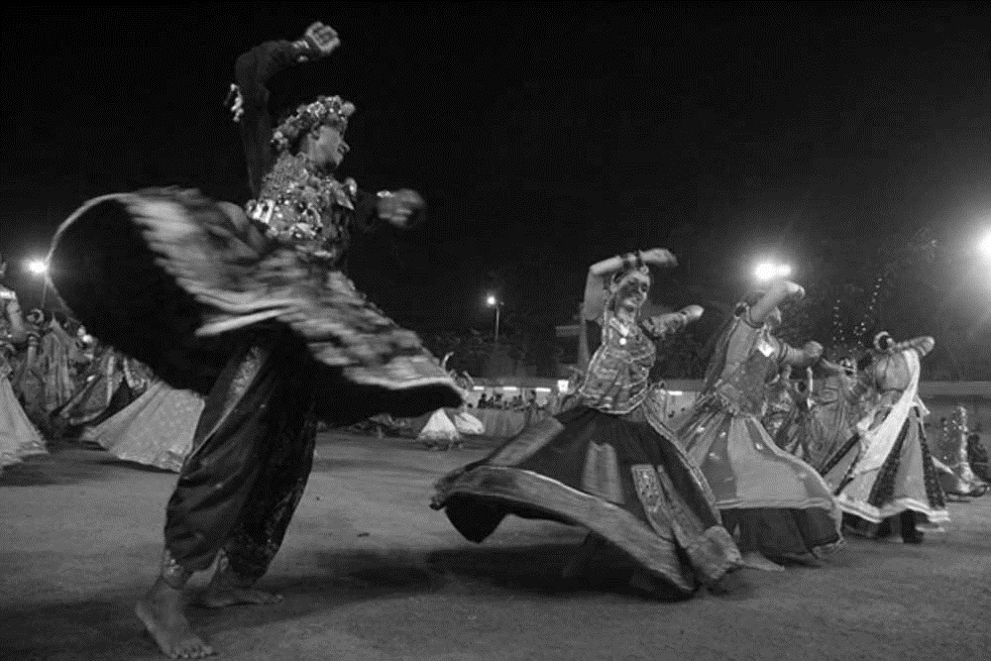

Singaporean food:

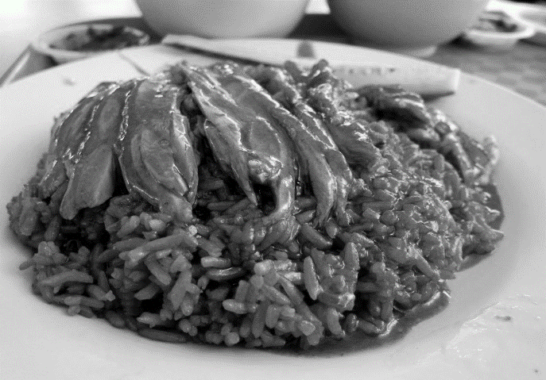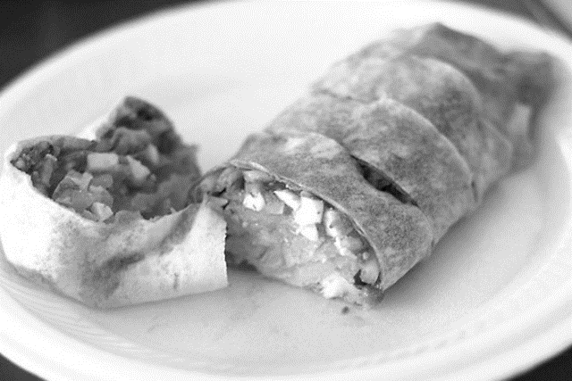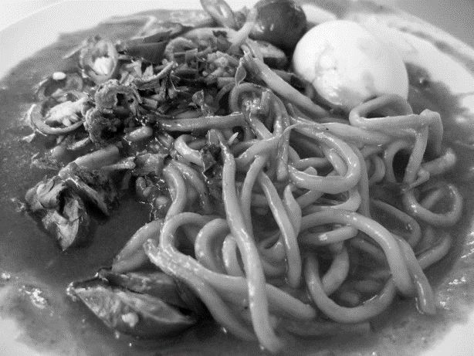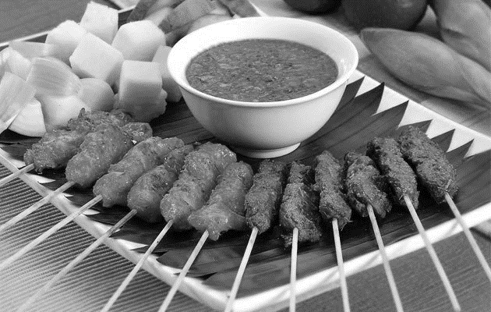Satay

Duck Rice

Popiah

Mee rebus

Satay

Political Geography

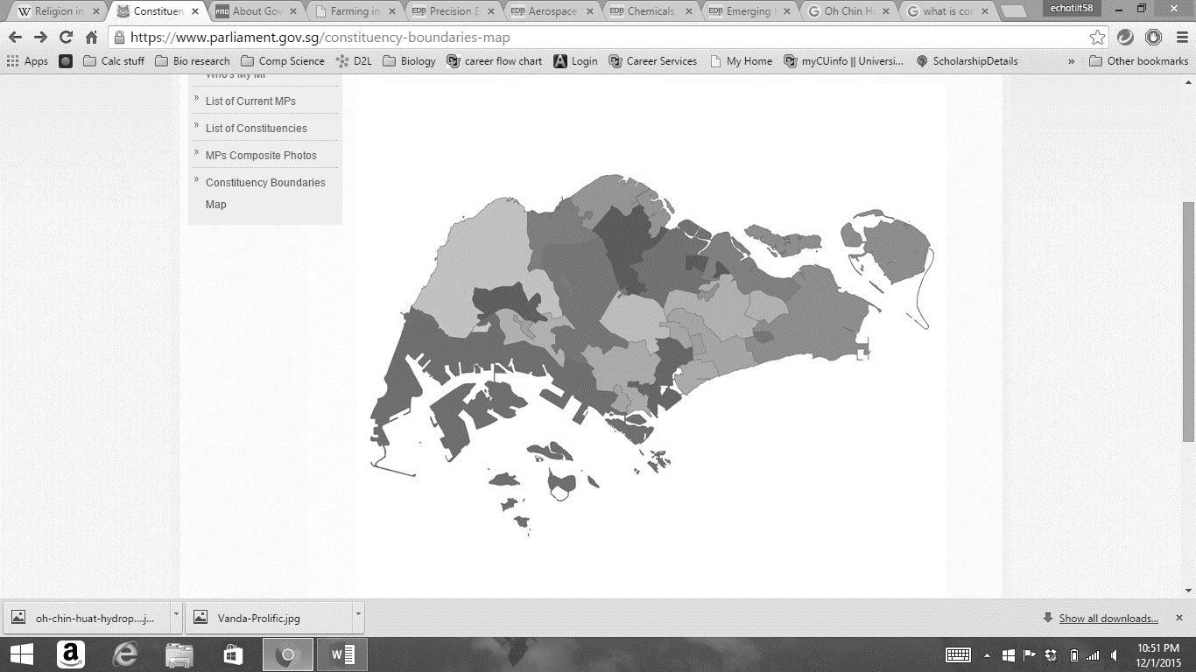The map below shows the Constituency boundaries enforces in Singapore:

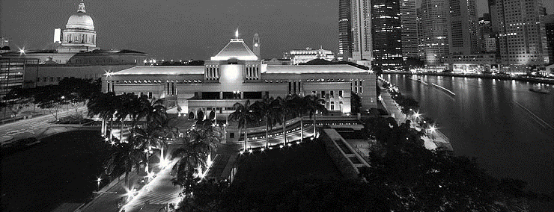The three largest of these constituencies consist of the West Coast GRC that is highlighted in purple, the East Coast GRC highlighted in blue, and Chua Chu Kang GRC located north of West Coast GRC and highlighted in green. These 32 constituencies distinguish a body of voters who elect a representative official.

The Executive, Judiciary, and Legislative branches of government are regulated through the Singaporean Constitution. The Head of State of Singapore is the President. Along with this, the executive consists of the Cabinet which accounts for the legal progressions of the Government. The Legislative Branch of the government consists of the parliament and the function of the Judiciary is to administer justice to the public. Furthermore, the Prime Minister of Singapore is appointed by the present President. With the help of the Prime Minister the President also appoints other ministers as members of the parliament.

Agriculture

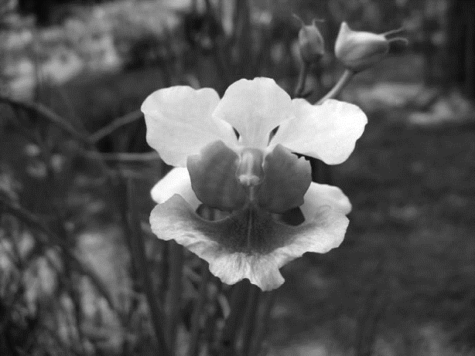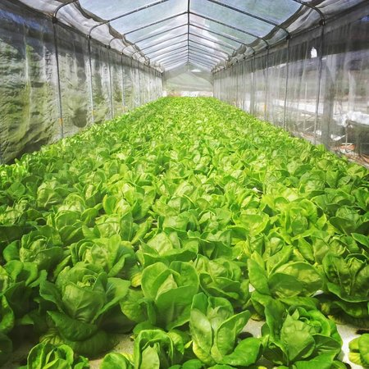Singapore has a particularly interesting organization for their agriculture. They established an infrastructure called agro-technology parks. Of the total land area of 1,465 hectares allocated for these parks about 700 hectares of it consists of approximately 200 farms. These 200 farms produce livestock, eggs, milk, fish, vegetables, fruits, orchids, and ornamental and aquatic plants. Singapore is known to be a major exporter of cut orchids. The orchid business in Singapore has steadily increased from its beginnings in 1955 with $5000 annually to a multi-million dollar business today. Specific Agrotechnology farms are dedicated to different production. Some farms produce leafy vegetables such as lettuce, bayam, and gailan while others are used to produce aromatic herbs like basil, thyme, chives, and parsley.

Some of these farms include the Kok Fah Technology Farm located in Sungei Tengah Agro-technology Park, the Oh Chin Huat Hydroponic Farms located in Nee Soon Agro-technology Park, and the Toh Orchids located in Sungei Tengah Agro-technology Park.

Industry, Manufacturing, and Services

Over the years Singapore has developed a successful financial stance to surpass some of its neighbors. For example, the GDP for capita for Singapore on 2013 was $55,000 while Hong Kong’s was $38,000, and USA’s being $53,000. As we see here Singapore has become a very profitable business region among East Asia. We also see here that Singapore rose to be able to even surpass USA.

Singapore is majorly dominated by a tertiary market. Some of their many services include Health and medicine, communication, transport, electronics, and food. There are over fifty hospitals over the broad span of Singapore. This specialization has made Singapore particularly healthy. Furthermore in their service industry, there are over 3,000 restaurants as of now in Singapore. Although given its compact size with a land area of 714 square kilometers, this figure is not too surprising given the diversity in the culture present in Singapore. Furthermore, there are over 16,000 busses and 26,000 taxis active in the transportation service in Singapore.

Chemicals research and exports is also a large component of the industry in Singapore. Some of the major Chemical plants consist BASF, DOW Chemical, Sinopec, SABIC, and ExxonMobil. These major chemical plants are the top 6 competitors in the industry. Some automotive manufacturing companies in Singapore consist of BMW, Mercedes, and Audi.



Architecture

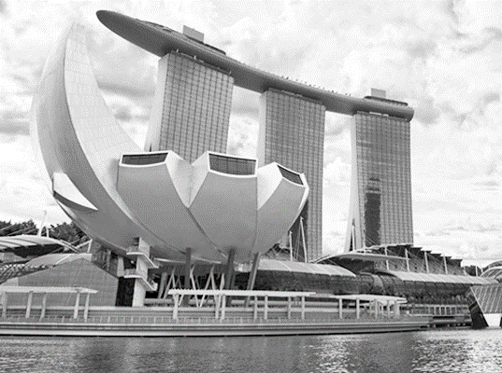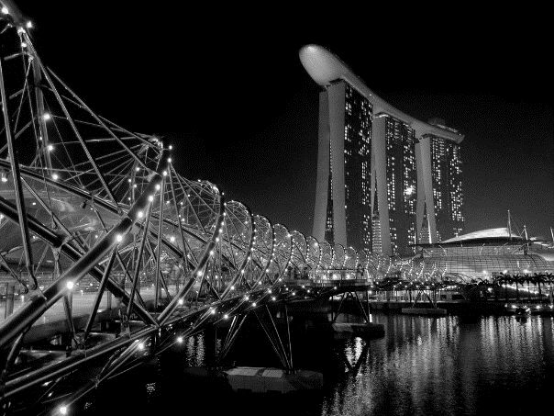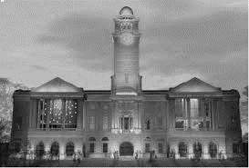Singaporean architecture portrays a very diverse spectrum of buildings and structures. These many structures and buildings were heavily influenced by the colonization of the British in 1819 and the ever more diverse culture present in this country. One such building constructed under the British influence is the Victoria Theatre and Concert Hall. Furthermore, as presented in the religions section, there exists a diverse selection of architecture that is very distinct dependent on each religion. The temples for the Hindus, the mosques for the Muslims, and the Churches for the Christians all exhibit very unique structure and representation. Along with these buildings there exists beautiful structures such as the Gardens by the Bay, and the Helix Bridge. Nonetheless, the most mesmerizing sight as the moon rises is the Singapore skyline

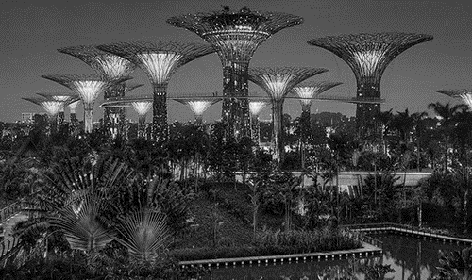

Singapore News

On the Sunday of December 8, 2013, 27 people were arrested for a protest that was sparked by the death of a foreign worker in a traffic accident.

-December 9, 2013

Leader from around the world and thousands of Singaporeans attend founding Prime Minister Lee Kuan Yew’s funeral.

-March 30, 2015

Air pollution from Indonesia’s slash and burn method of farming has caused some school cancellations.

-September 25, 2015

Pastor Kong Hee and church officials was accused of fraudulent use of $36,000,000 in helping promote his wife’s pop music career.

-Oct 22, 2015

All news clippings from CNN and New York Times

Works Cited

<https://www.lta.gov.sg/content/dam/ltaweb/corp/PublicationsResearch/files/FactsandFigures/Stats_in_Brief_2012.pdf>

<http://www.nptd.gov.sg/portals/0/homepage/highlights/population-in-brief-2014.pdf>

<http://population.sg/resources/population-composition/#.Vfeqp1-COSM>

<http://www.singstat.gov.sg/statistics/visualising-data/charts/age-pyramid-of-resident-population>

<http://www.asiancenturyinstitute.com/migration/200-singapore-s-migration-dilemmas>

<http://www.eastasiaforum.org/2014/04/02/singapores-impotent-immigration-policy/>

<http://worksingapore.com/articles/live_7.php>

<http://www.ava.gov.sg/explore-by-sections/farms/land-farms/farming-in-singapore>

<http://www.pmo.gov.sg/about-government>

<https://www.parliament.gov.sg/constituency-boundaries-map>

<http://sethlui.com/best-local-famous-foods-to-eat-singapore/>